**ROUTE53 AND EBS (ELASTIC BEAN STACK)**

* Domain name purchased in Godaddy
* Steps to create configure a domain name to the route 53

1. Open AWS management console
2. Open Route53 and create a hosted zone
3. Give the name, description and type as public hosted zone and create

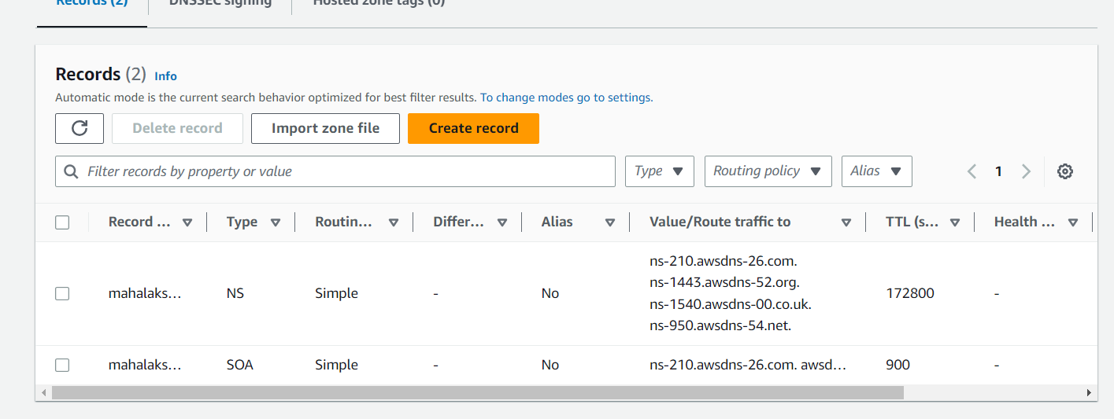

1. It will create 4 ns

* NS – name server
* SOA – start of application
* So the request will go to Godaddy
* Go to Godaddy mange your domain name and change the name servers

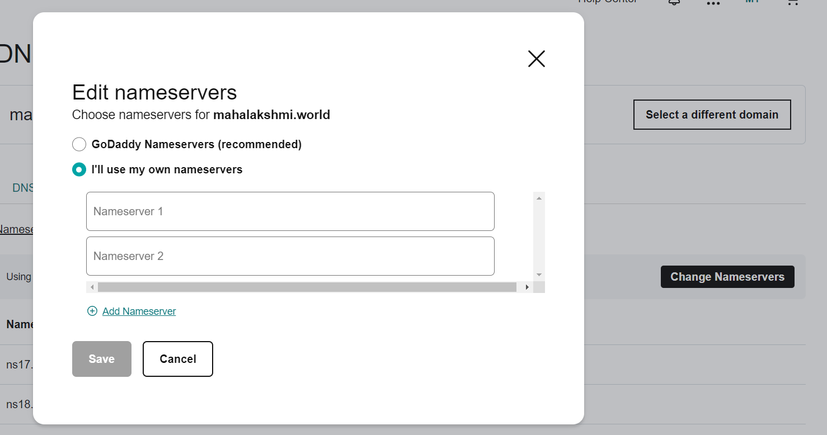

* Copy the name servers from route 53 and paste it in godaddy

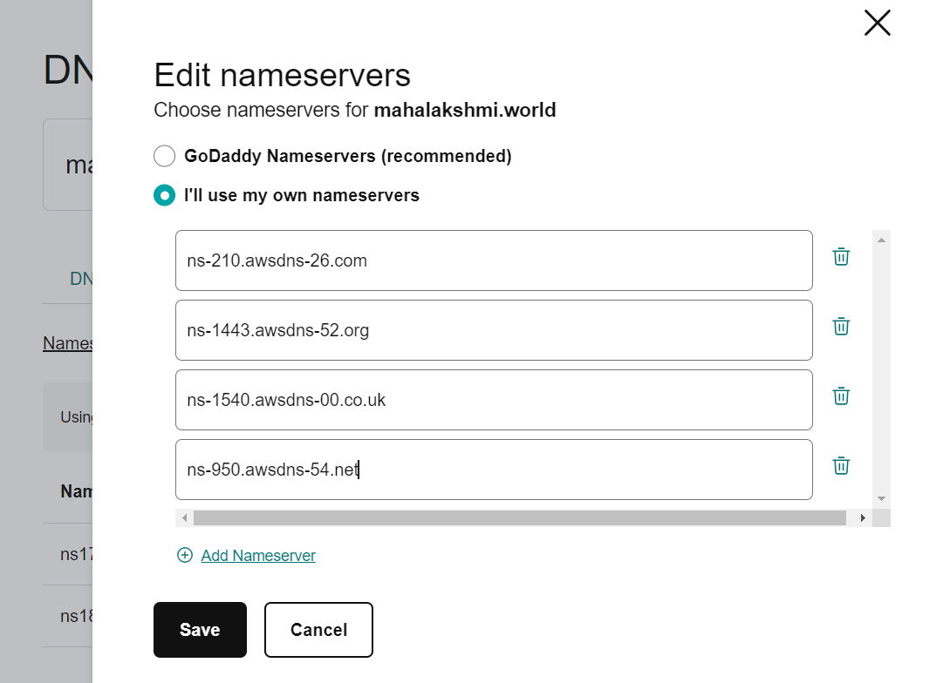

* Create a record
* Choosing routing policy as Simple routing
* We can use this to receive the same response for all our clients.
* In configure records page click Define simple record
* Before this create an instance with a user data in additional settings



* By clicking the public IP address we get the result

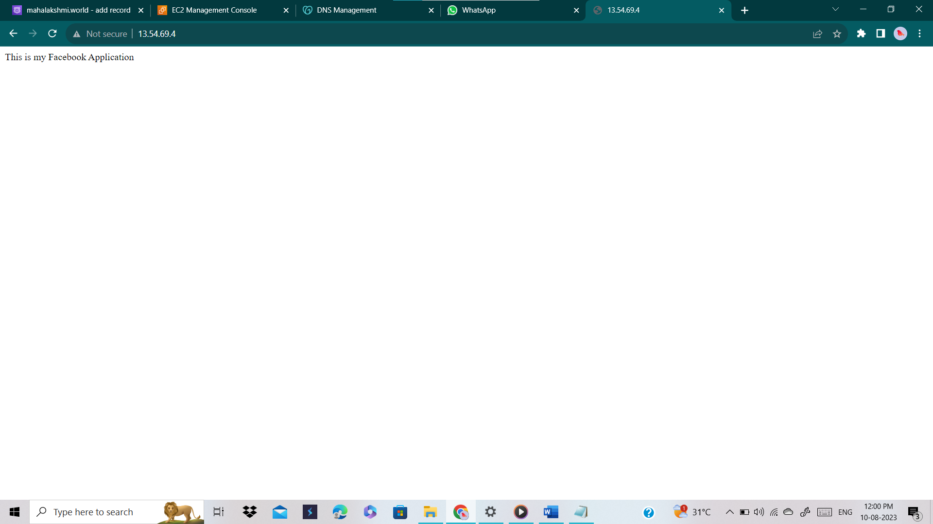

* In define simple record, by adding the public IP address of an instance that we created we can get the same result by giving the domain name in chrome.
* Change the TTL as 1 min.

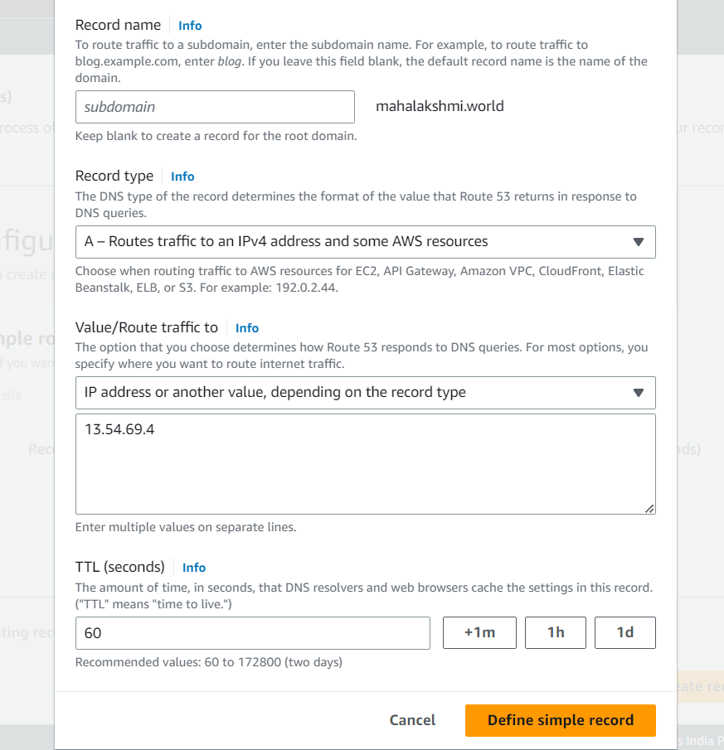

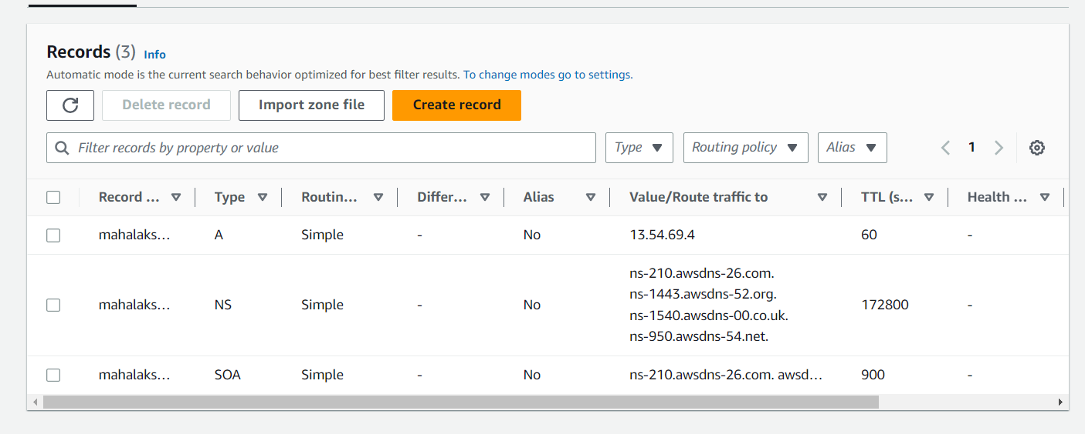

* And the result is here

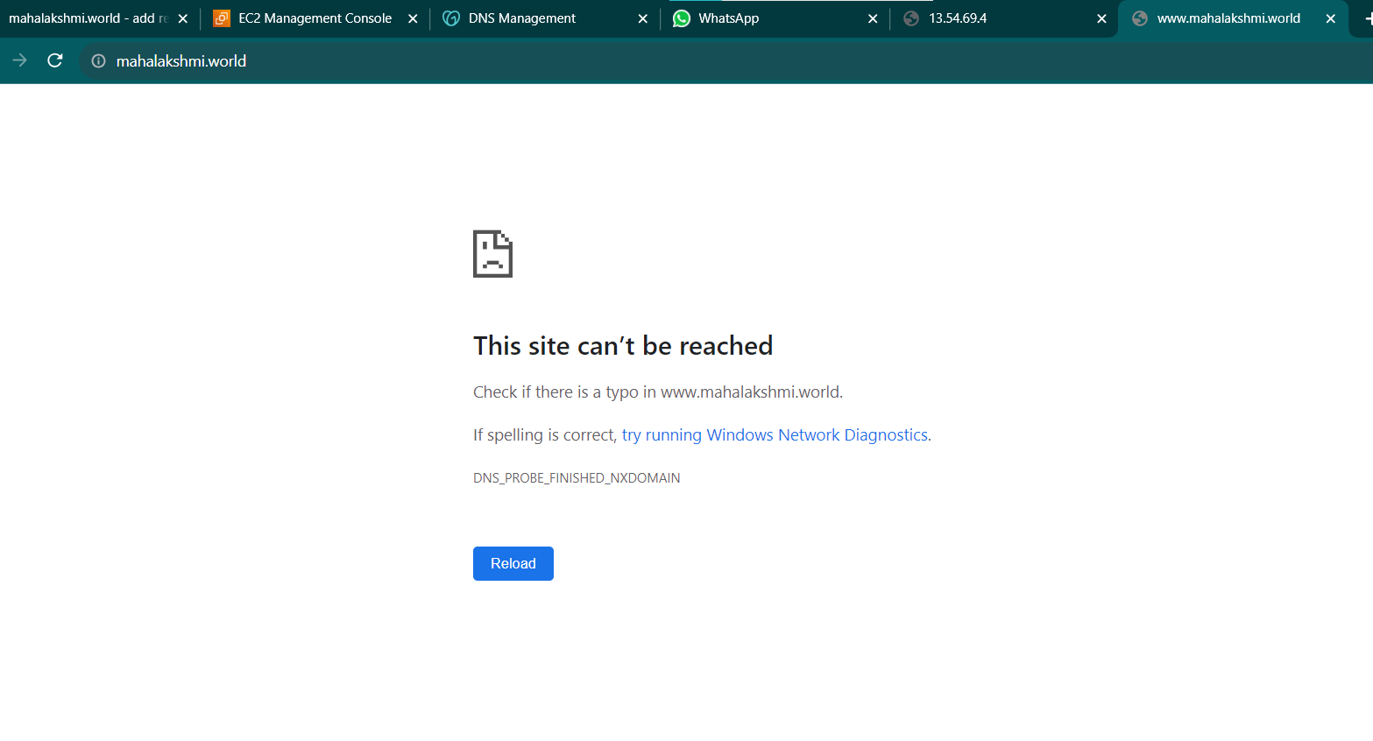

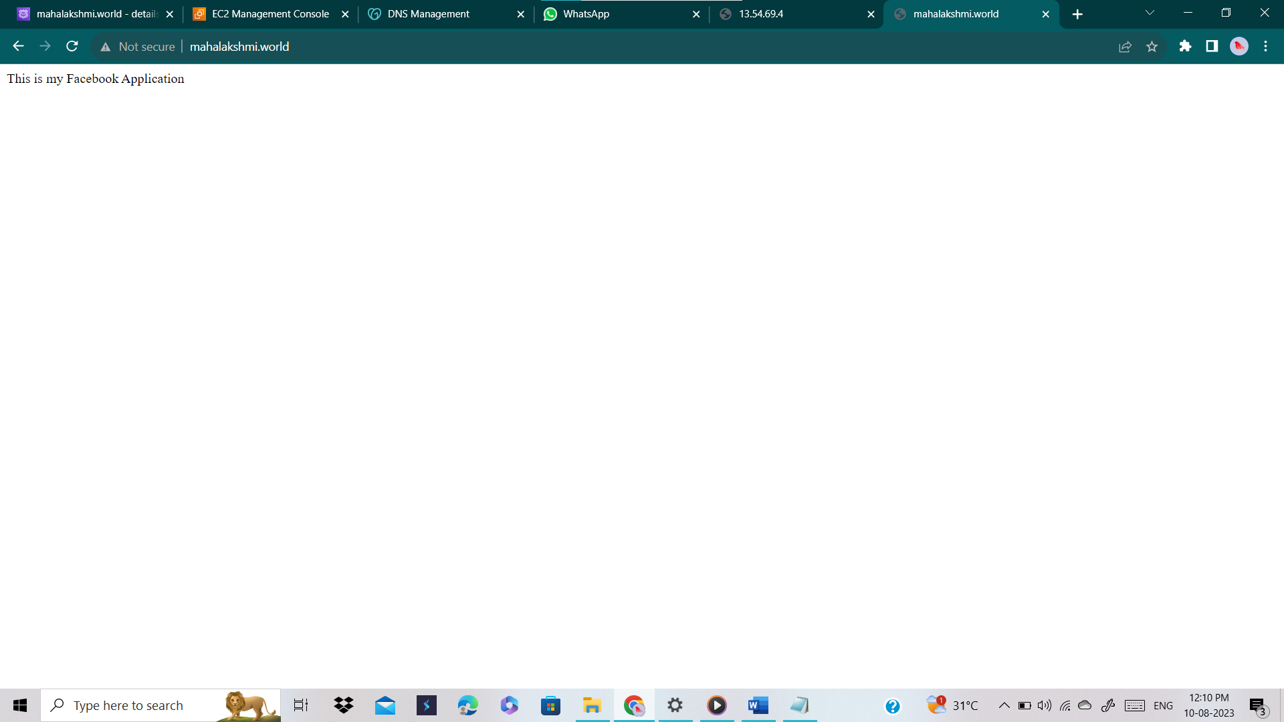

* Now we gonna change the routing policy as Geolocation
* Create another instance with different user data
* Now I am going to set the r53 instance region as India and Sydney server region as Sydney
* By setting like that if we access from India we’ll get the result as **“this is Facebook application”** and if we access from Sydney we’ll get the result as **“this Instagram application”** .

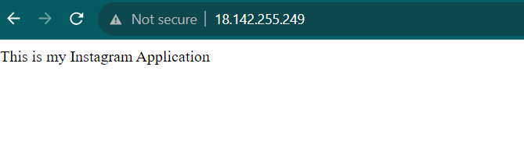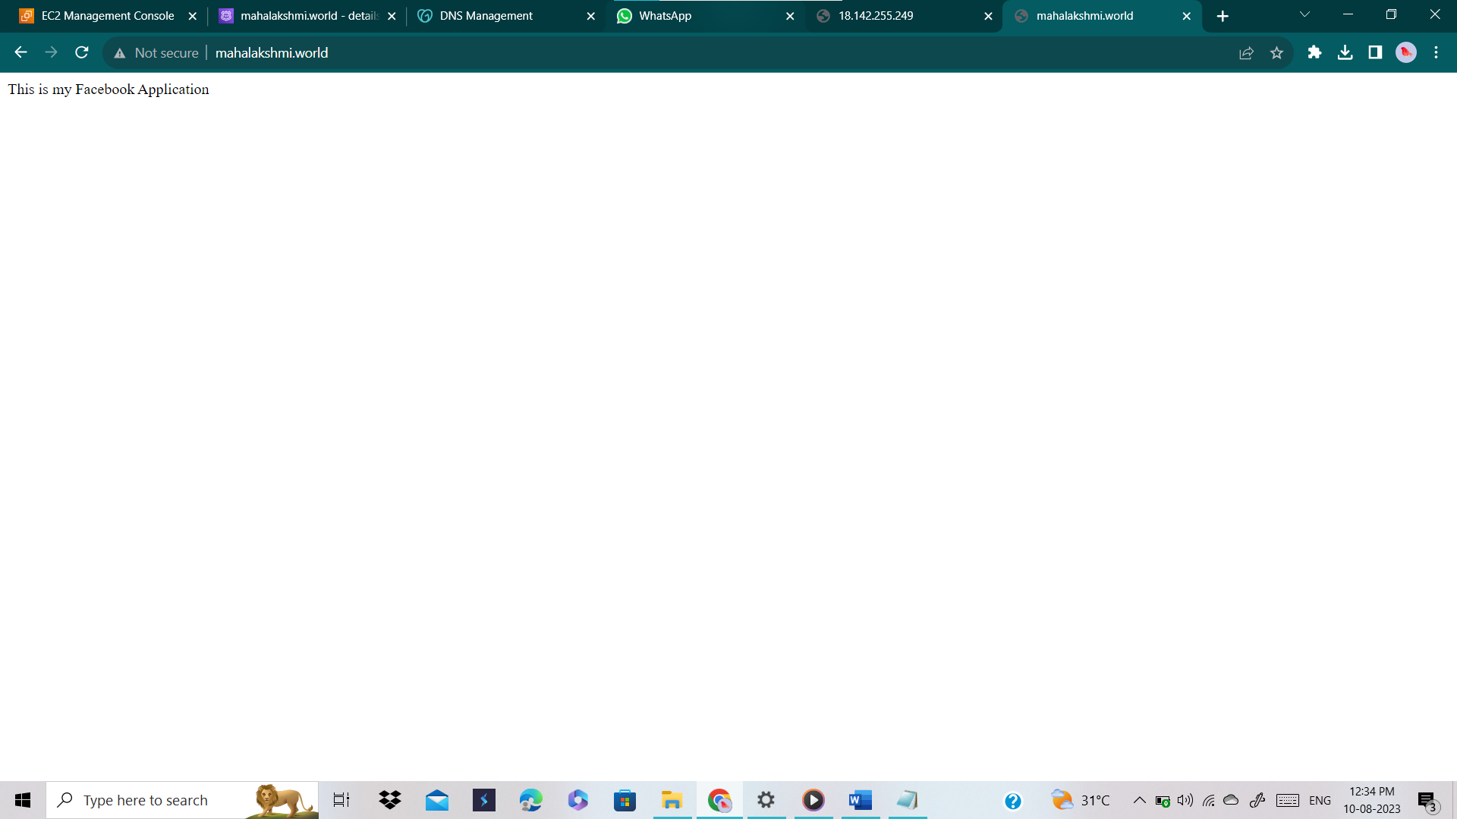

* Tried to create a record with simple routing policy and the record type as “A “and the result is here, type A cannot be created with the same name and type.
* So we cannot set more that 1 record (Routing policy) (task 1)

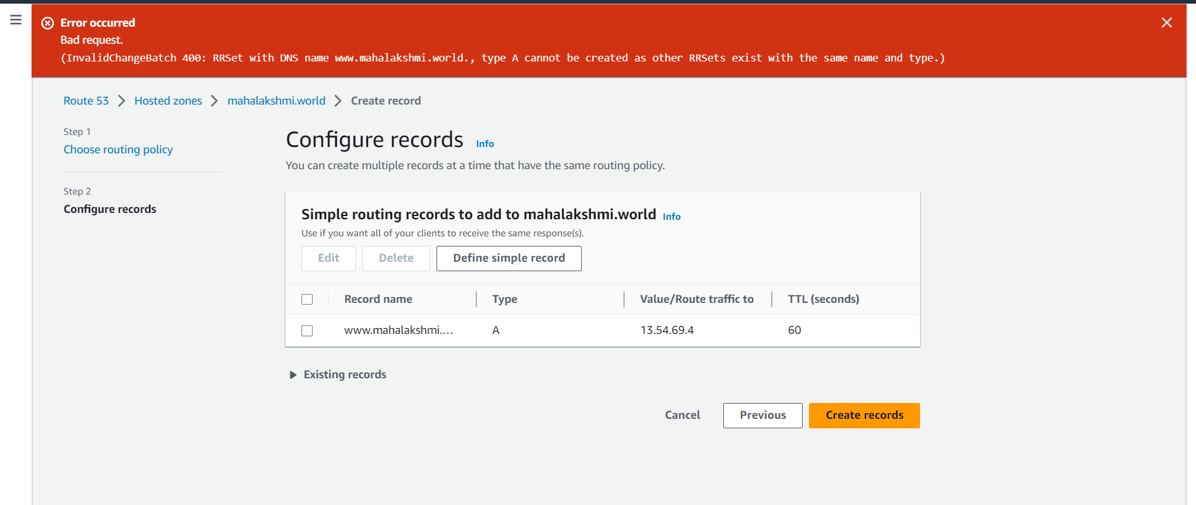

* Now we are going to change the record type routing policy as “Failover “
* Here I am going to set the ‘myinstance’ server as a primary and my Singapore instance that I created in Singapore region as a secondary
* And for a primary server we have to do the health check id because Failover routing policy will work if the primary server goes down or stopped then the secondary server will work.
* My content in ‘myinstance’ server is “this is snapshot application”
* My content in Singapore server is “this is Instagram application”

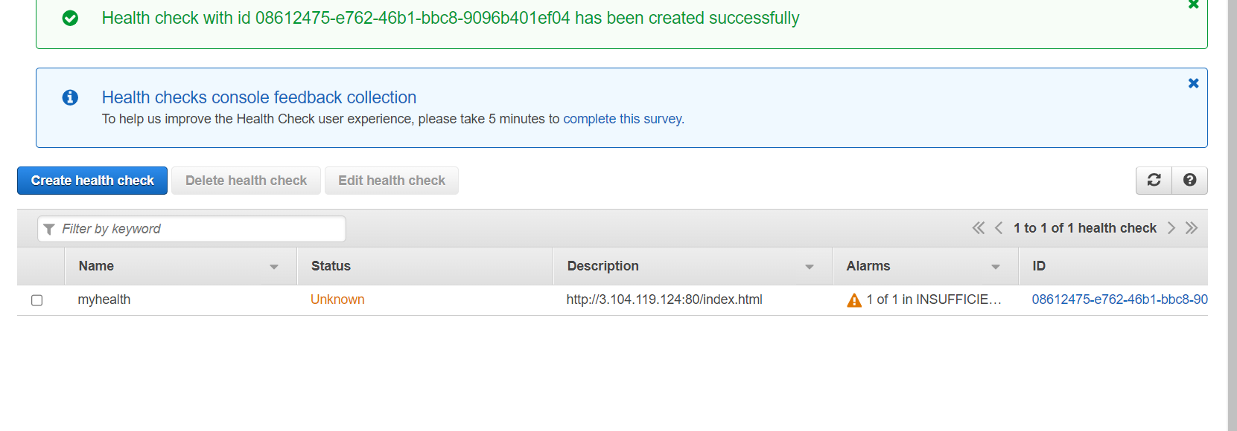

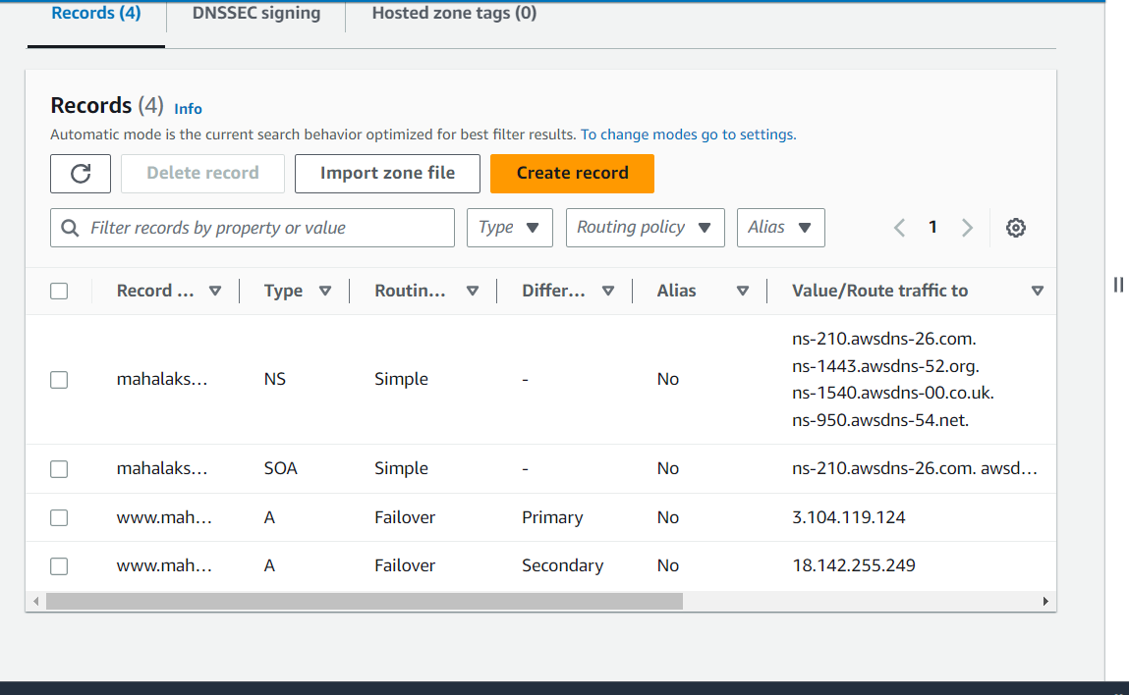

* The result we got is

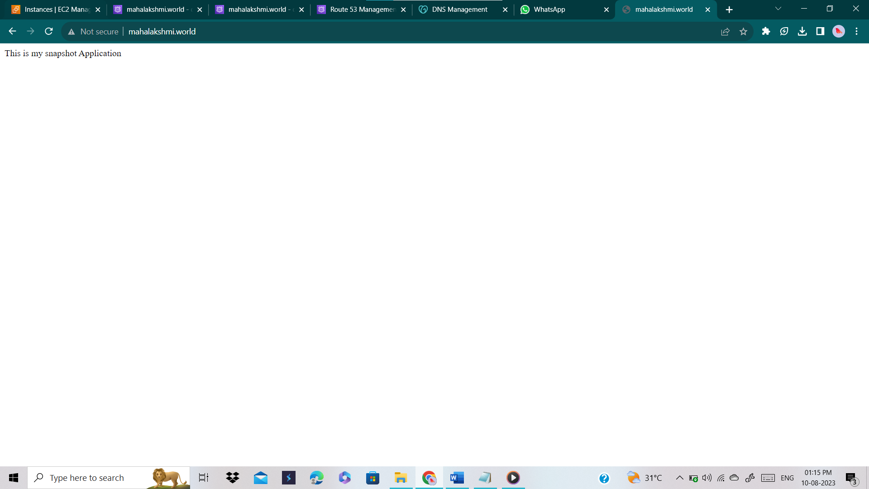

* Now if the primary server goes down SNS will send a notification and by clicking the domain name we’ll get the result as secondary server content
* To get I am going to stop the primary instance

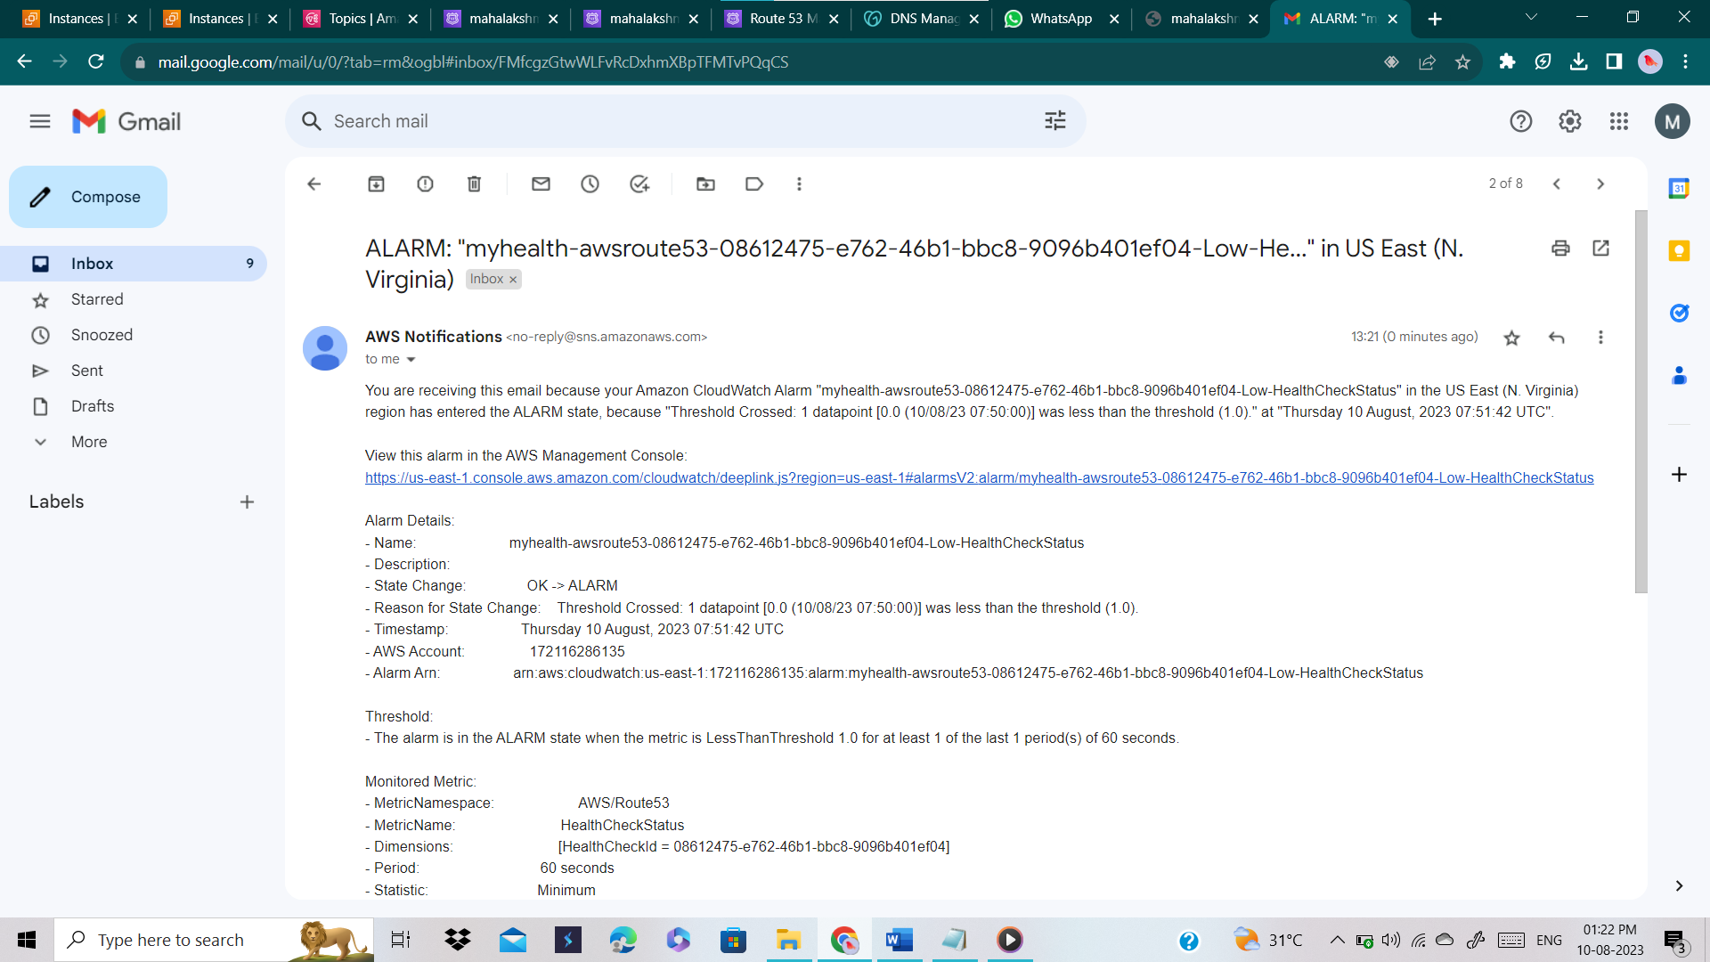

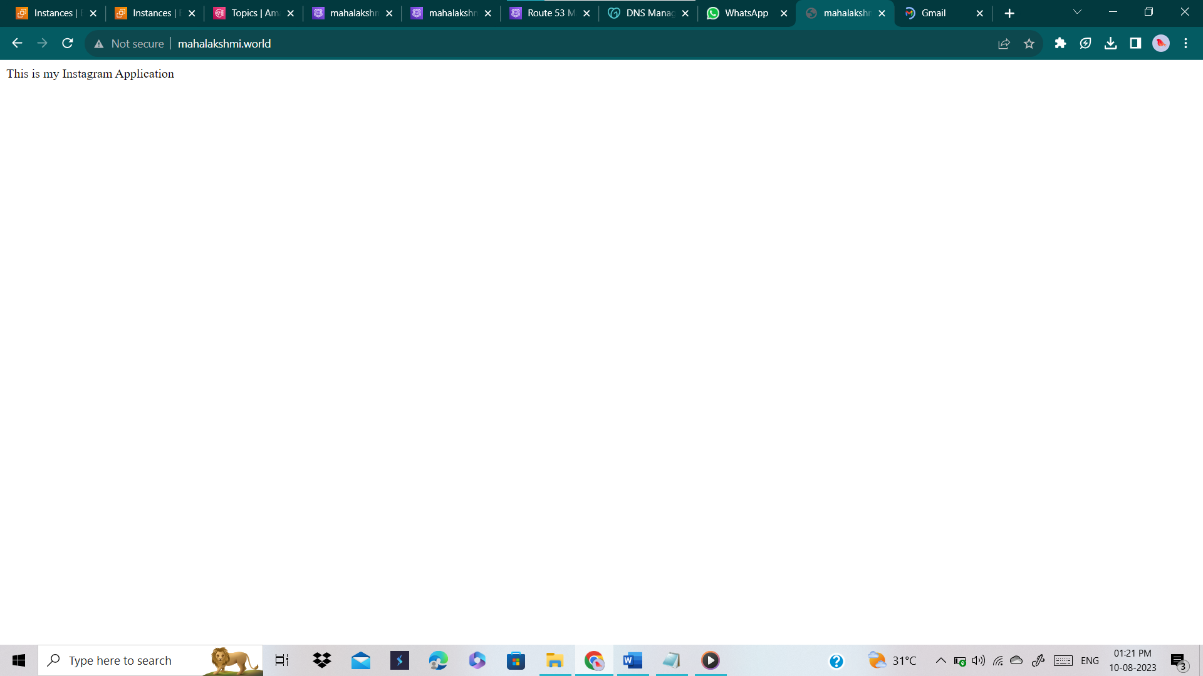

**TASK 2:**

* Now we are going to change the routing policy as “Latency”

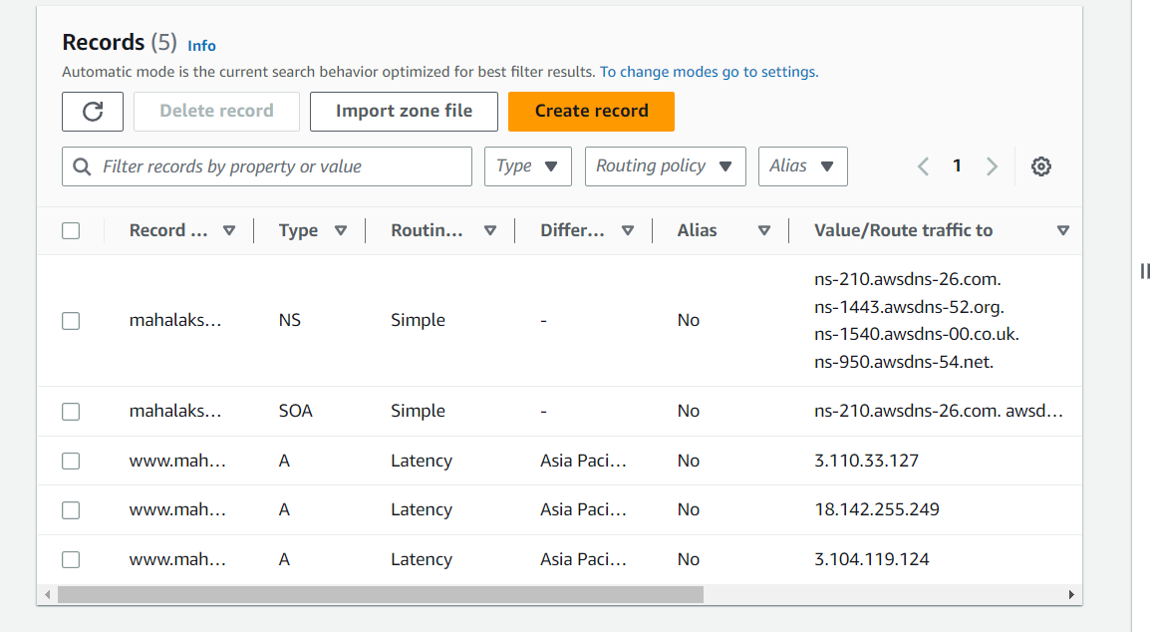

* I created a record in a region Mumbai, Singapore and Sydney since my location is closer to Mumbai my result is “this is my Mumbai region”

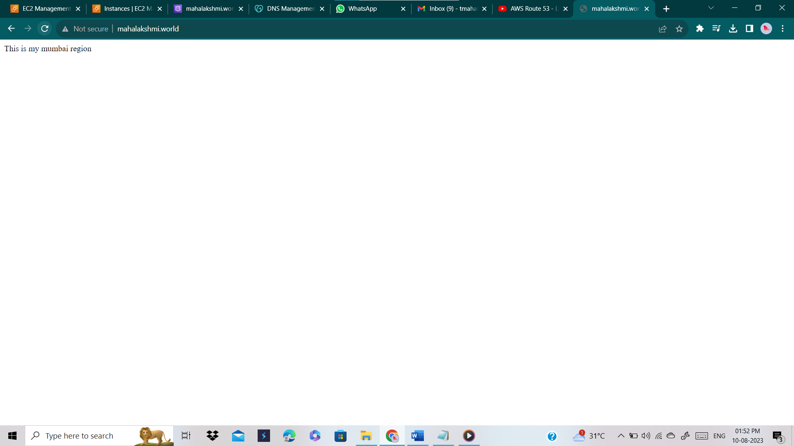

* If I delete the Mumbai record I’ll get the result as content in Singapore region which is “this is Instagram application”
* Deleted the record Mumbai and now I have Singapore and Sydney records only

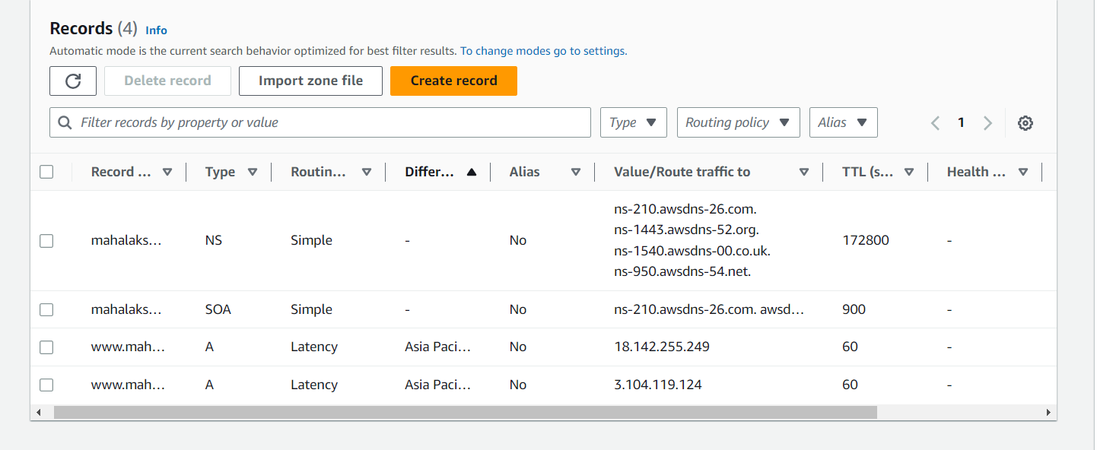

* And the result I got is

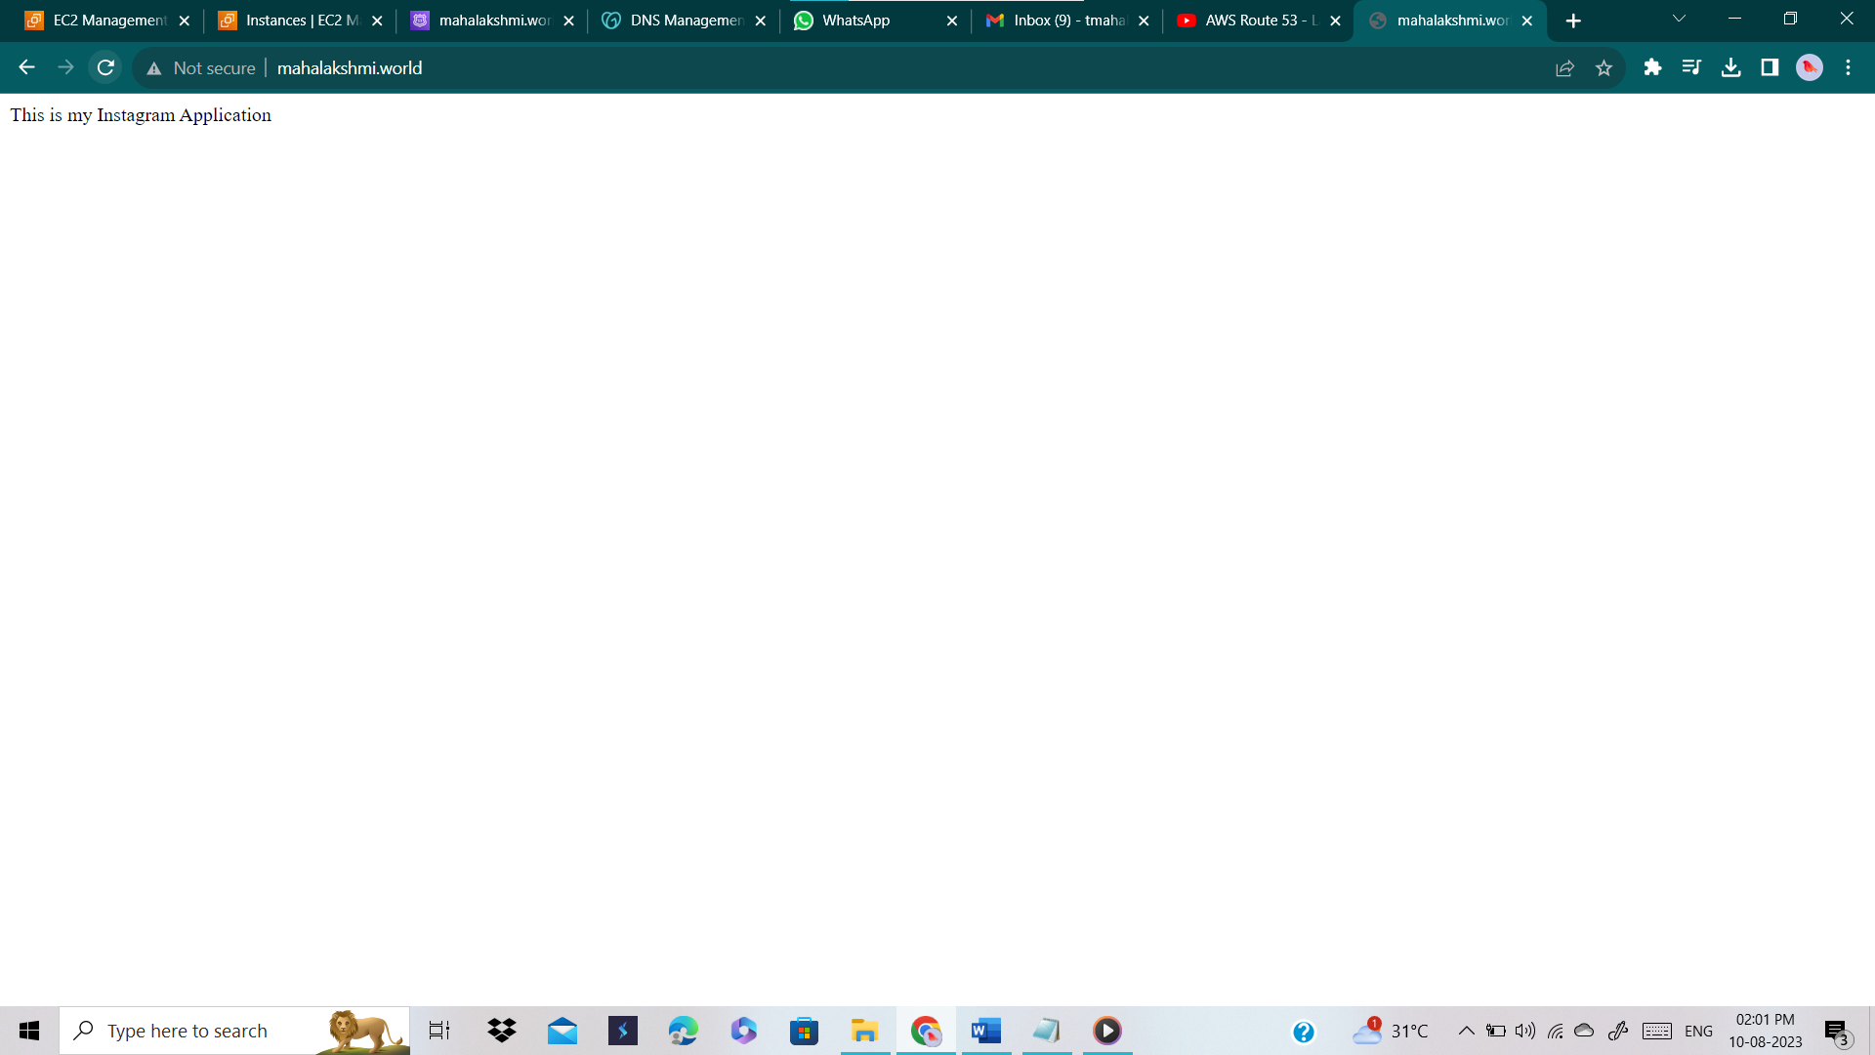

**TASK 3:**

* Select Routing policy as Weighted

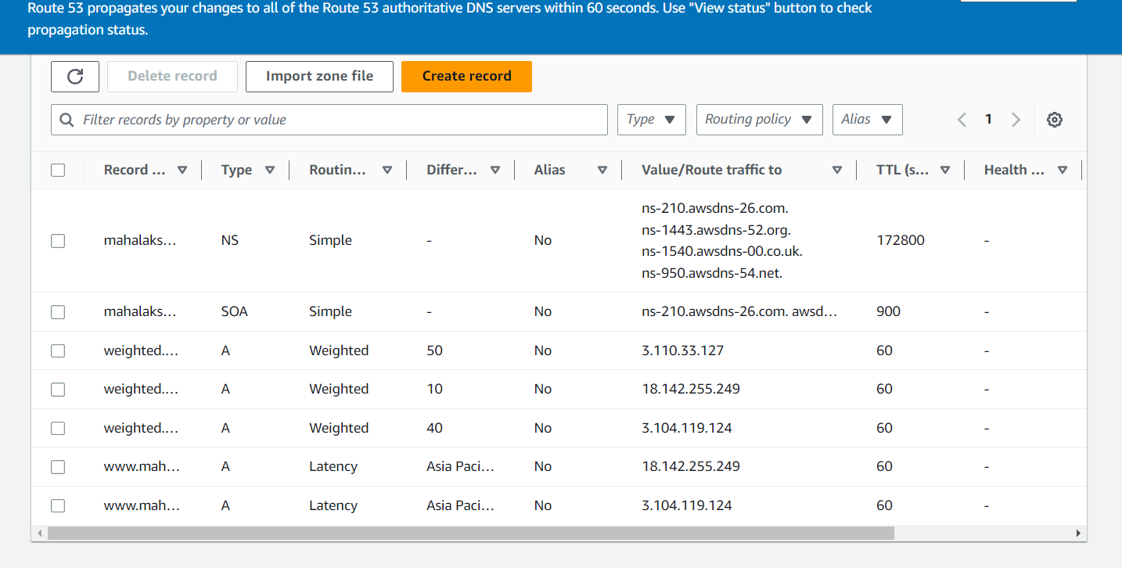

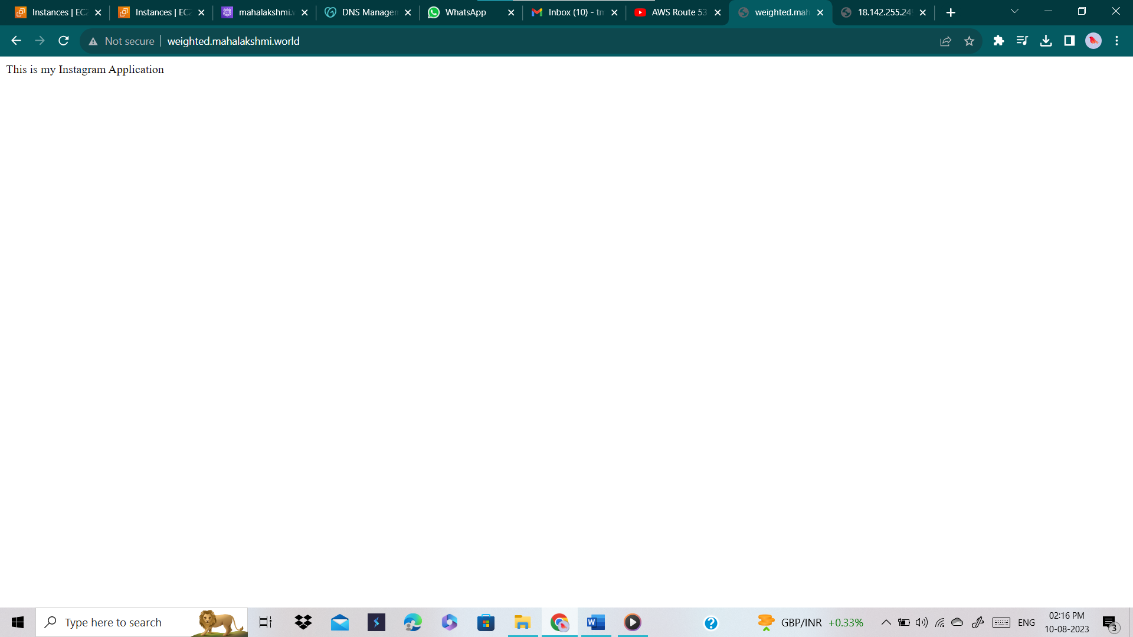

* After refreshing sometime I got this

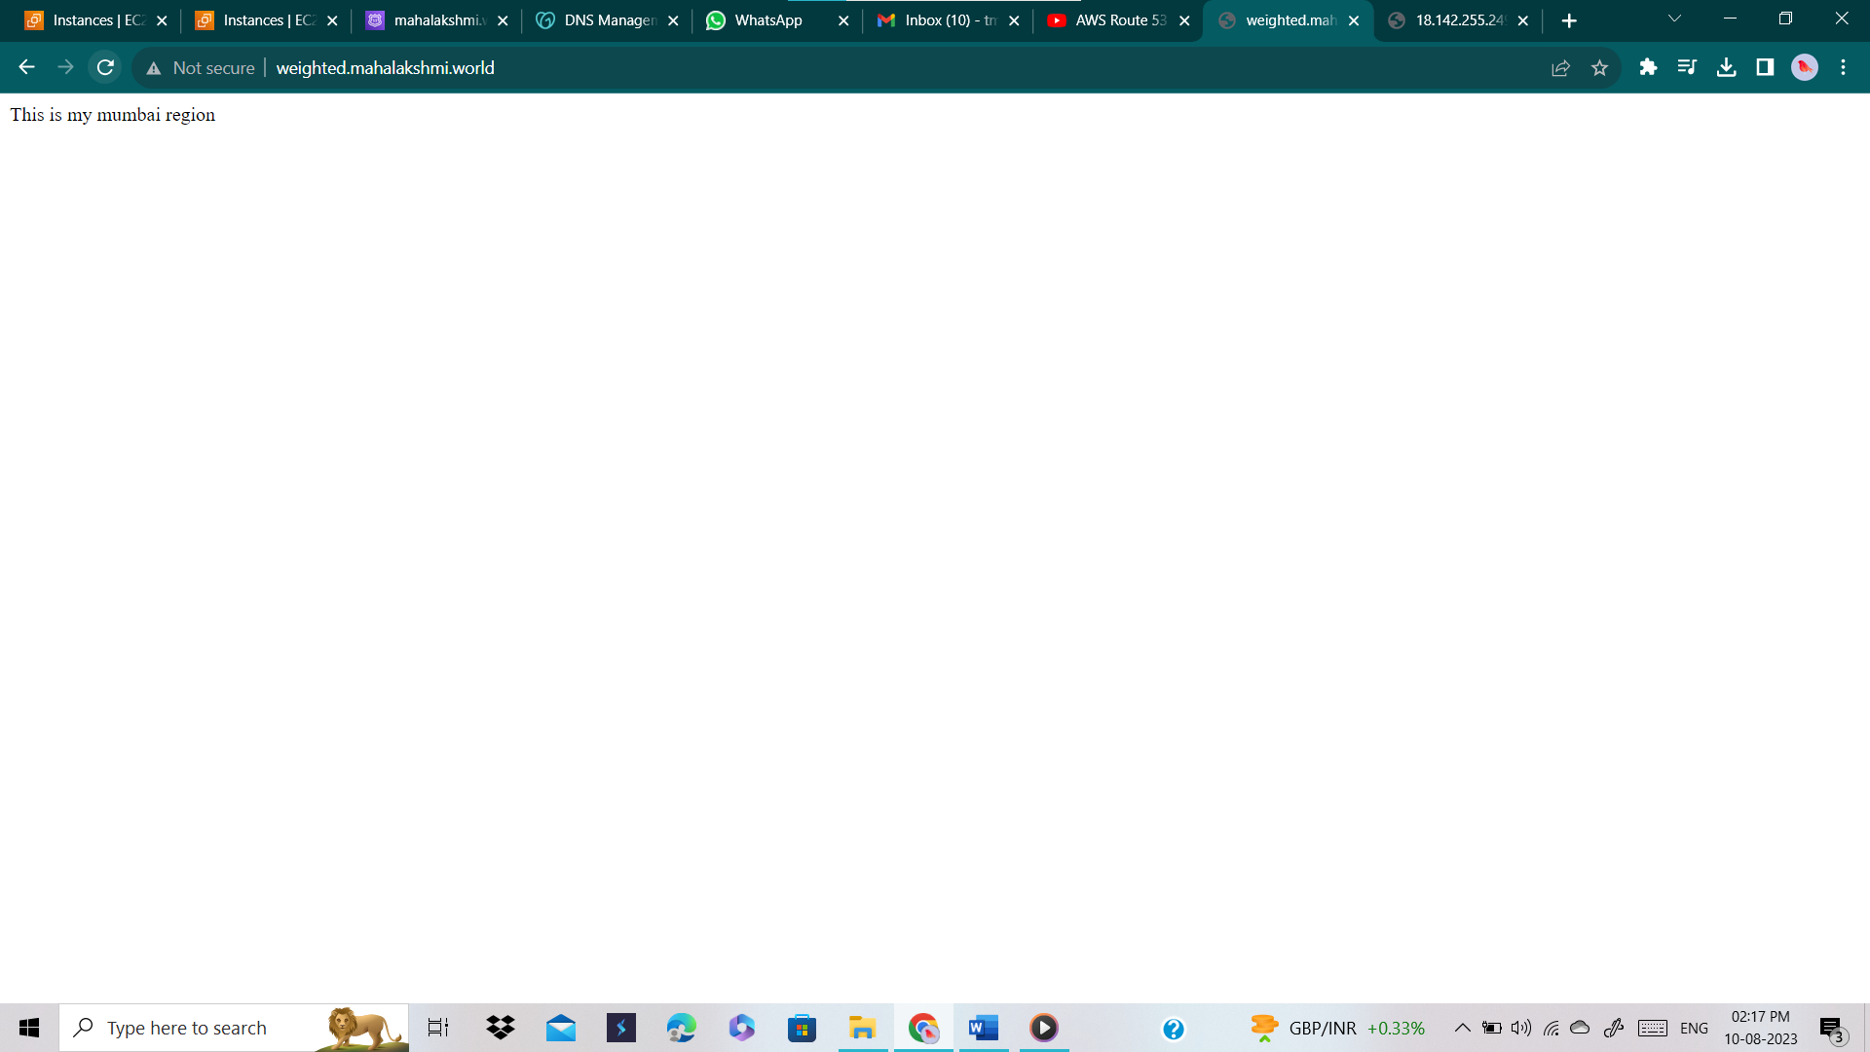

* I said above we can’t set more than 1 record (routing policy), yes we can’t when we set the same domain name for all routing policy.
* If we set the sub domain name differently we can set more than 1 routing policy. Here are the results, (**TASK 1**)

